Niroj koirala
SSN 187.1914
May 20, 2022
Problems in Mega-cities

Introduction
Mega-cities are the urban areas having more than ten million inhabitants. According to the United Nations, there are currently 28 megacities in the world, and it predicts 40 megacities in the world by the end of 2030, it also projects mega problems like income inequality, sanitation, housing, transport, and sustainable development. (United Nations Department of Economic and Social Affairs, 2018). In 1950 there were only two megacities New York and Tokyo and by 1980 they were joined by Sao Paulo and Mexico City. In 2010 there were over 20 megacities. The rise of megacities is happening faster than any time in human history. While Asia consists of more than half of mega-cities, it is predicted that over 9% of world’s population will live in megacities by 2030.
Mega-cities are also known as urban phenomena of the 21st century as they are the epicenter of rapid industrialization and urbanization. The wide range of production and industrialization make them the gateway of the global economy. The earning opportunities in these cities has been the major attraction for the people to move into these mega-cities. The other infrastructure such as transportation, electricity also attracts people to this huge hotspot of economic activity. These cities have enormous potential to reduce poverty and improve the quality of life for the large number of populations. It also gives an exposure to the people to showcase their talent and get it to the global level. The rapid growth in population can be seen as a positive aspect for a city as it fulfils the labor demand and skilled manpower helps the city to drive further and faster.
The rate in which the people are moving into the cities are off the scale as the UN predicts that more than two third of population will live in the urban areas by 2050. The mega-cities are one of the many great thing’s mankind has ever created as it makes people wealthier, healthier, and more productive. The mega opportunity in these cities often comes with the cost of mega-problems for themselves and the world. The problems such as electricity, transportation, pollution, and load in housing are the first waves of problems megacities face due to overpopulation. Cities only take 3% of the world's total surface but they consume more than 75% of total energy. This disparity in the energy consumption will create a huge demand of energy in mega-cities. The failure of the government to meet these demands forces people to use non-renewable energy resources which gives rise to environmental problems. Air pollution has always been in an increasing trend in the megacities as 80 % of world total greenhouse gases are emitted only in mega-cities which causes health complications to the people of these cities.
The failure of Mega-cities to grow, adapt and upgrade itself with respect to the population growth is seen as the fundamental aspect for the rising problems in megacities.
The problems in mega cities are very closely related to each other and the governing body.
The rapid growth of population means more demand on housing, which limits open spaces and green parks further supporting the problem of pollution. Failure to estimate the growth rate of population and react early will lead to Unplanned Urbanization which has a vast consequence to follow. The failure to separate industrial sectors and residential areas will create the demand and supply unbalance of energy and water facilities. This imbalance will have its toll on both industries and people as the scarcity of electricity reduces the rate of production of goods and for the people it affects their quality of life.
Climate change, a problem of today and biggest possible threats for the future gets most of its contribution from Mega cities. From residential heating to industries needing energy, non -renewable resources are the ones to meet the demand which has its widespread consequences.
Moreover, carbon monoxide and greenhouse gases coming from the industries and production areas degrade the environment further. The process of accommodation for the incoming population causes limitations on green areas and forests which will ramp the degradation of our environment putting the future of the world at risk.
The problem of inequality has significantly been notable in these mega cities. It has also been known as a place made for the rich by poor individuals. The huge gap in income, rights and accessibility of facilities has also been a major problem of mega-cities. “Rich keeps getting richer and poor keeps getting poorer” is a very common phrase used by economists to describe mega-cities. From people living in skyscrapers with the world in their feet to people living in slums with no access to the basic food and water facilities, Mega cities continue to be in rising mode. People living in slums are deprived of education, health facilities and many more. The problems of slums cannot be ignored as there are more than 6.5 million people living as slums in the mega-city of Mumbai which in context has more population than the entire state of Maryland.
The increasing trend of population in these megacities has had its toll on rising hate crimes. In the context of United States in New York - Newark urban area the hate crime has been a significant problem along with the problems of housing and transportation. The traffic in this area is second to none and narrower road make it accident prone. Moreover, more than 50 thousand homeless are forced to live in road because of load in housing sectors and government failure accommodate those people.
Based on a preliminary investigation of Problem in Mega-cities the following research question and hypothesis have been developed.
r1- will megacities still be able to attract people after the failure of housing and transport systems to cope with rapid population growth??

h1- it is believed that people from rural areas will continue to view megacities as a step to quality life without acknowledging that their arrival contributes to further problems on transport and housing.

Methodology
Not all research requires the collection of new data. Sometimes researchers use existing data sources, such as research and data collected by others. Data most widely used by researchers is gathered by government agencies such as the U.S. Census Bureau, State Agencies, and local units of governments.
For purposes of this preliminary research assignment, an extensive review of the existing literature was conducted using academic journals. This approach saves time and money and was endorsed in class. Based on research findings, others may wish to extend my work by using some of the other research methods commonly used by social scientists such as surveys and interviews.

Literature review
Mega-cities, Mega- problems have been a simple phrase since 2007 when world cities have reached a point of hyper urbanization. Earning opportunities and Quality of life has attracted a huge number of populations into mega-cities but this attraction comes at the cost of massive problems. The huge number of incoming people tends to create an overwhelming demand on transport and housing facilities which makes life difficult for both incoming population and city’s residents. Not only does the growing population cause problems on infrastructure but also it has its environmental, social, and economic impacts. The following review of literature provides the problem of megacities and concludes the causes and solution method.
A huge number of studies and research have been carried out focusing on the problem of mega cities and its deep causes, but very little research has been done to find out its effective solution and ways to minimize its threats. One of the findings by the research team led by Zhou focused on the water quality issue in the rising Asian megacity. The researcher here analyzed air quality, hydrology, and the water flow to point out the causes of water pollution. The rapid growth in population has heavily affected the city in a negative manner. Efficient and equitable water, wastewater and stormwater management for the megacities is becoming an increasingly complex task (Varis,2007). The author also stated that insufficient drainage in the prone flood city has caused surface water to get mixed with the wastewater and into the river which only increases the problem. The failure of the local government to provide piped surface water to every resident has forced the people to use groundwater which drives land subsidence. The author blames the incompetence of governing bodies and a random planning without studying the geography of city to be the major cause of water scarcity in the regi`on. Even after identifying the problem of water facilities in the city and its deep causes, the method to overcome the problem has been very slow.
Also, another identical research pointed out the economic impacts of natural disaster in mega cities (2015) where the causes of flood has been analyzed in megacities of Sao Paulo. The author here subsequently puts a blame on poor management and lack of vision from the local government to the economic impacts this city faces. The author also mentioned that fast growth of population in Sao Paulo has overwhelmed the transport and housing facilities which results in limiting green open spaces and increased deforestation which is an invitation to natural disaster. The frequency of this natural disaster tends to give birth to the new problem of mental and physical stress to the residents of this region. This mental and physical stress to the residents has comparatively resulted in less productivity in the workplace than before. The damage in infrastructure takes a huge portion of the city's budget to rebuild which slows down the pace of city’s development.
“The plans for the world’s next largest city are incomplete.” (Vaz2022). The author mentioned that in the coming 20 years Delhi is going to surpass Tokyo to become the largest city in the world. The next global phenomenon is not at all prepared to handle the incoming population. The problem of overpopulation is notably visible now, imagining a 20 years’ time from now without proper management is scary. The problem of housing, electricity, and traffic infrastructure is the major problem that governing bodies of megacities try to resolve. The scale in which the population is growing makes the cities hard to manage in all political, social, and economic fonts. Author also described that the current scale of population growth will double the number of slums which then will be described as a planet of slums. Furthermore, a heavy traffic in the city takes three hours of their day just to travel from workplace to home. A similar case analysis done by the team of Maddison in the city of Lagos have found out the same identical problem. More population means more demand for energy which often forces cities to use non- renewable resources. The expansion of built-up areas to accommodate the growth in population lead to increased use of CO and so2 emission which degrades the air quality in the region. The author also pointed out that rural-urban migration could be the main region for rapid increase in population growth, land expansion and poor air quality.
Many different plans and policies have been made to tackle the major problems in megacities from both government and private sector. To deal with the traffic congestion a company named boring company has built a 3D tunnel network which can be a significant way towards solving one major issue of transportation and traffic congestion. Also, the Paris climate agreement in 2015 to reduce global warming by switching to renewable resources was an important step towards a safe and healthy city. However, the plan in place today is not expected to overcome the pace of the problem which has been increasing exponentially.
Taking a serious approach and making a long-term management plan with respect to geography and population density is the first step in solving this crisis. Collaboration of government and private investors to ensure sustainable development is also a proven fundamental for good megacities around the world. Strong rules against the excessive use of greenhouse gases and promoting electrical appliances is the necessity of today's world. The concept of recycling and reuse and its advantages is a subject every resident must be aware of. Giving a tax benefit for the electrical appliances users will significantly encourage others to switch to electrical appliances which results in less usage and extraction of non-renewable resources. This eventually improves the quality of air and reduce the health effects caused by air pollution which is a step towards a good city.
Results:
Out of 28 current megacities in the world, 3 megacities have been excluded from the findings as their Census Bureau weren’t able to complete the full Census. The following graph and other findings are the proof to showcase the acceptance of my Hypothesis.

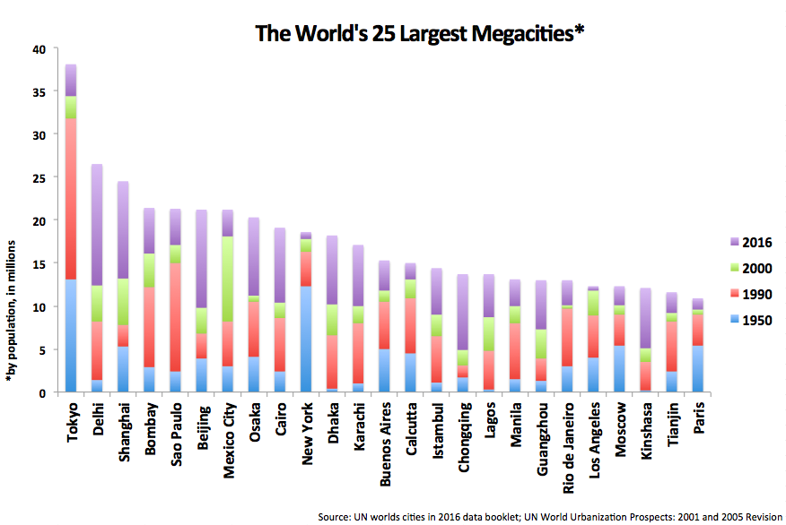
The attraction to the mega-cities has never faded for the people seeking quality life even if they failed in the housing and transportation sector. Mega-cities such as Bombay and Delhi have failed to adapt with rapid population growth which completely crashed their housing and transport facilities. Even after the failure of these foremost infrastructure Bombay attracted more than 8 million population in the last decade. In 2010 the city of Bombay had 33 percent of its total population living as slums with an increasing trend. In 2019 concluded that more than 6 million people live as slums which accounts to 55% of total population. The increment of slums are the people from rural areas who migrated long after the UN declared housing crisis in Bombay proved that people saw megacities as a step towards quality future. Similarly other Mega-cities facing huge problems of transportation like Dhaka, Sao Paulo have increasing population trend. Currently more than 3 million people migrate to cities every week for the opportunities and attractiveness megacities offer.
Some major cities in Asia such as Busan and Nagasaki had seen significant decreases in population from the year 2000. Also, several cities in the country of Eastern Europe have experienced a similar population decline. Similarly, here in the United States, more than seven hundred thousand people moved out of the New York-Newark area. This decline of population growth has mainly occurred in the low fertility but developed region. Also, findings proved that people moving from these cities have moved to bigger mega-cities for quality life.
The research has resulted that people are attracted to megacities and will continue to do so without understanding the consequences of their arrival to the city which further solidifies my hypothesis.

Conclusion:
The following research concluded that Megacities are the places where the future happens first. The opportunities and exposure in these cities invite many populations but unmanaged urbanization which plants the seeds of a mega-problem. Problems like waste management, transportation, scarcity of water can all be tackled with long term vision, effective planning, and collaboration among stakeholders. Governing bodies in mega-cities should focus on sustainable development and target zero emission of greenhouse gases. Tax subsidy for renewable energy users and implementing the standard policy set by the Paris climate accord by the government is a must to reduce the greenhouse gases and rise in temperature. For any upcoming cities, geomorphology (study of land) should be done to understand the density capacity of that region because early and proper planning would only make a rising city to a successful megacity.

Bibliography
- Plos One, Vol. 14, Issue 7, p1-17, 07/11/2019, Luo Pingping, Kang Shuxin, Apip Null, Zhou Meimei, lyu jiqiang, Aisyah Siti, Binaya Mishra, Regmi Ram Krishna and Nover Daniel .
- Habitat International, volume 45, part 2, p106-113, January 2015, Eduardo Amaral Haddad, and Eliane Teixeria
- Modern economy, volume 10, NO 2, September 2019, Akubue jideofor Anselm
Challenges of Mega Cities: Lessons for Evolving Sustainable Nigerian Cities.
- Environmental pollution, volume 203, page 235-242, August 2015, GERD A. folberth and steven T Rumbold.
- Journal of South American Earth Sciences, Volume 112, Part 1, December 2021,
Adolfo Quesada, Roman Jose, Pablo Castro-Chacon and Sergio Feoli Boraschi
- Habitat International, volume 108 part 3, February 2021, Eric Vaz and Bruno Damasio.
- South African Geographical Journal 102:2, pages 209-222, March 2020, Lerato Shikwambana and Lesiba Thomas Tsoeleng.

